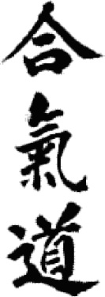
Komyokan Aikido Association
Dan Grade Examination List
1/25/2012

This document details the Dan Grade regulations and examination requirements for the Komyokan Aikido Association under the direction of T.W. Ezra Shihan.

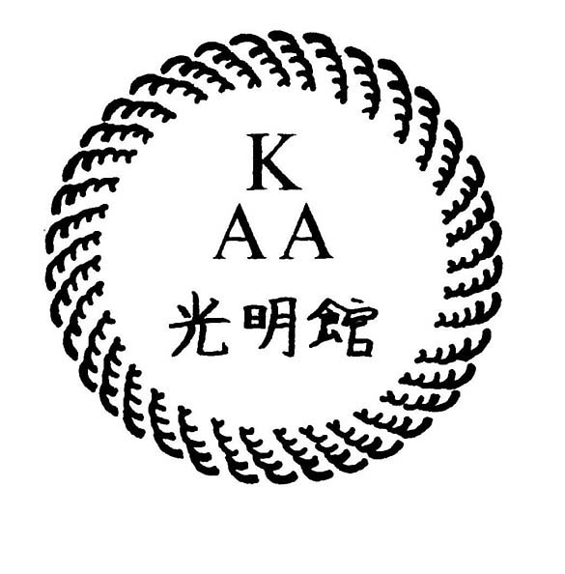

REGULATIONS

Candidates wishing to test for Shodan to Yondan require Ezra Shihan’s permission and must apply at least six months in advance. Promotion to Godan and above is on the recommendation of Ezra Shihan and is awarded by Hombu at the Kagami biraki in January of each year. Please prepare thoroughly for your examination; do not leave anything to chance.

- SHODAN: Minimum one year after 1st Kyu, with 100 practice days.
- NIDAN: Minimum two years after Shodan, with 200 practice days.
- SANDAN: Minimum two years after Nidan, with 300 practice days.
- YONDAN: Minimum three years after Sandan, with 400 practice days.
- GODAN: Minimum five years after Yondan.
- ROKUDAN: Minimum six years after Godan.
- NANADAN: Minimum twelve years after Rokudan.

SHODAN:

SHOMENUCHI

- Ikkyo: T, S & H

Nikyo: T, S & H
- Sankyo: T, S & H
- Uchi kaiten sankyo: T
- Yonkyo: T, S & H
- Gokyo: T & S
- Iriminage: T & S
- Shihonage: T
- Kaitenage: T
- Kotegaeshi: T
- Sumiotoshi: T
- Udekimenage: T
- Kokyunage: T
- Jiyuwaza: T, S & H

SHOMENUCHI UCHI IRIMI TENKAN

- Shihonage: T
- Kotegaeshi: T
- Kokyunage: T
- Advanced kokyunage: H
- Jiyuwaza: T & H

KATATEDORI

- Ikkyo: T, S & H

Nikyo: T, S, & H
- Sankyo: T & H
- Yonkyo: T & H
- Iriminage: T (jo, chu, ged)
- Shihonage: T & H
- Kaitenage: T & H
- Tenchinage: T
- Sumiotoshi: T
- Udegaraminage: T
- Soto kaiten katagatame: T
- Uchi kaiten katagatame: T & H
- Kokyunage: T, S, & H
14. Jiyuwaza: T, S, & H

RYOTEDORI

- Ikkyo: T, S & H

Nikyo: T, S, & H
- Sankyo: T, S & H
- Yonkyo: T, S & H
- Iriminage: T & H (jo, chu, ged)
- Shihonage: T & H
- Kotegaeshi: T (jo, chu, ged)
- Tenchinage: T, S & H
- Sumiotoshi: T & H
- Haishin undo: T
- Kokyunage: T & H
- Soto kaiten kokyunage: T
- Uchi kaiten kokyunage: T
14. Jiyuwaza: T, S, & H

MOROTEDORI

- Ikkyo: T

Nikyo: T
- Sankyo: T
- Yonkyo: T
- Iriminage: T
- Shihonage: T
- Kotegaeshi: T
- Udekimenage: T
- Udegarami jujinage: T
- Kokyunage: T
11. Jiyuwaza: T & H

KATADORI

- Ikkyo: T, S & H

Nikyo: T, S, & H
- Sankyo: T, S & H
- Yonkyo: T, S & H
- Shihonage: T, S & H
- Kotegaeshi: T
- Udekimenage: T
- Kokyunage: T, S & H
- Jiyuwaza: T, S, & H

YOKOMENUCHI

- Ikkyo: T, S, & H

Nikyo: T & S
- Sankyo: T & S
- Yonkyo: T & S
- Gokyo: T & S
- Iriminage: T (jo, chu, ged)
- Shihonage: T & H
- Kotegaeshi: T & H
- Udekimenage: T
- Kokyunage: T & H
- Uchi kaiten kokyunage: T
- Jiyuwaza: T & H

CHUDAN TSUKI

- Ikkyo: T

Nikyo: T
- Sankyo: T
- Yonkyo: T
- Gokyo: T
- Kaitenage: T
- Iriminage: T
- Tenchinage: T
- Udehishigi: T
10. Kotegaeshi: T
11. Jiyuwaza: T

JODAN TSUKI

- Ikkyo: T
- Nikyo: T
- Sankyo: T
- Kotegaeshi: T & H
- Kaitenage: T
6. Iriminage: T
7. Shihonage: T & H
8. Jiyuwaza: T & H

USHIRO RYOTEDORI

- Ikkyo: T & H

Nikyo: T
- Sankyo: T
- Yonkyo: T
- Iriminage: T
- Shihonage: T
- Kotegaeshi: T
- Kaitenage: T
- Kokyunage: T
10. Tenchinage: T
11. Jiyuwaza: T & H

USHIRO RYO KATADORI

- Ikkyo: T & H

Nikyo: T & H
- Sankyo: T & H
- Yonkyo: T & H
- Iriminage: T
- Shihonage: T
- Kaitenage: T
- Kokyunage: T & H
- Jiyuwaza: T & H

USHIRO KATATEDORI KUBIJIME

- Ikkyo: T

Nikyo: T
- Sankyo: T
- Yonkyo: T
- Shihonage: T
- Kotegaeshi: T
- Kokyunage: T
- Jiyuwaza: T

USHIRO MUNEDAKISHIME

- Ikkyo: T
- Shihonage: T
- Kotegaeshi: T
- Sankyo: T
- Jiyuwaza: T

USHIRO ERI DORI

- Iriminage: T
- Kokyunage: T

KATADORI SHOMENUCHI

- Ikkyo: T

Nikyo: T
- Sankyo: T
- Yonkyo: T
- Shihonage: T
- Kotegaeshi: T
- Iriminage: T
- Udekimenage: T
- Jiyuwaza: T

KATADORI YOKOMENUCHI

- Ikkyo: T & H
- Nikyo: T & H
- Sankyo: T & H
- Yonkyo: T & H
- Shihonage: T & H
- Jiyuwaza: T & H

KATADORI JODAN TSUKI

- Ikkyo: T
- Iriminage: T

EXTRAS

- Essay
- Jiyuwaza
- Tachidori
- Jodori
- Tantodori
NIDAN

- As for Shodan plus:
- Mae geri kokyunage
- Yoko geri kokyunage
- Futarigake (2 ukes, any attack)
- Ninindori
- Bokken suburi
- Jo kata: nana no kata
- Essay

SANDAN

- As for Shodan and Nidan plus:
- Sanindori
- Jo kokyunage
- Jo kata: Ju san no kata
- Bokken: basic awasae (1 to 6)
- Essay

YONDAN

- As for Shodan, Nidan and Sandan plus:
- Henka oyowaza
- Kaeshiwaza
- Taninzugake (multiple attackers)
- Jo kata: San ju ichi no kata, Ichi no kata, Ni no kata, and San no kata
- Kumi tachi
- Bokken Advanced awasae
- Bokken kaishi no kata
- Aiki musubi no ken
- Jo versus bokken
- Tanto versus bokken

